Dbms-lab-8

Arshia Azeem 24k-0012

Task 1:
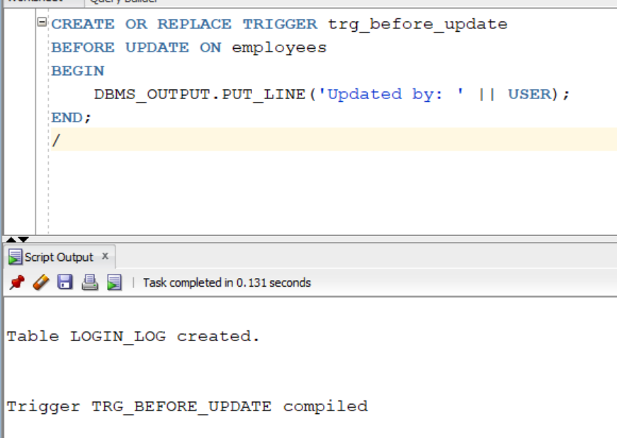
b)
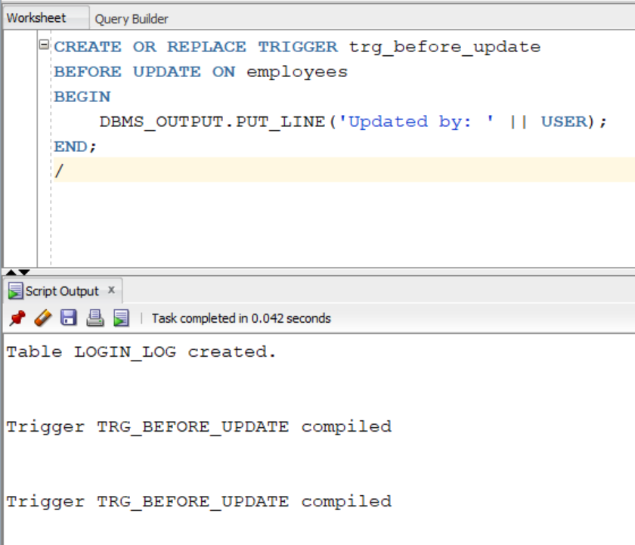
c)
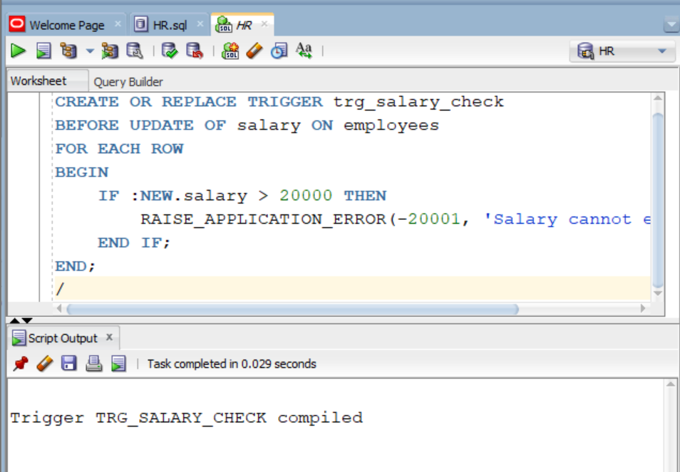

d) 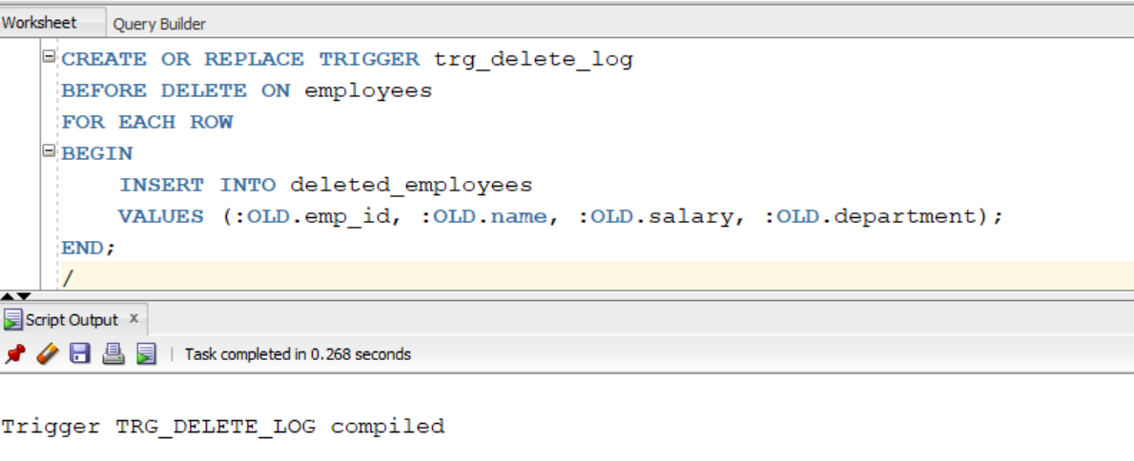

Task 2:
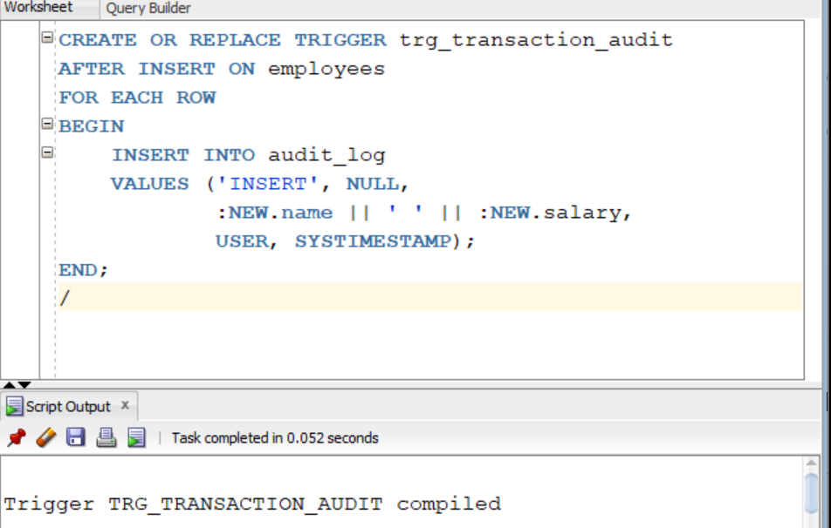

b)
CREATE TABLE DDL_LOG (
USER_NAME VARCHAR2(30),
OBJECT_NAME VARCHAR2(50),
ACTION VARCHAR2(20),
ACTION_TIME DATE
);

CREATE OR REPLACE TRIGGER trg_ddl_create
AFTER CREATE ON SCHEMA
BEGIN
INSERT INTO DDL_LOG
VALUES (USER, ORA_DICT_OBJ_NAME, 'CREATE', SYSDATE);
END;
/

c)
CREATE OR REPLACE TRIGGER trg_prevent_drop
BEFORE DROP ON SCHEMA
BEGIN
IF ORA_DICT_OBJ_NAME = 'EMPLOYEES' THEN
RAISE_APPLICATION_ERROR(-20002, 'Dropping EMPLOYEES table is not allowed');
END IF;
END;
/

Task 3:
CREATE TABLE LOGIN_LOG (
USER_NAME VARCHAR2(30),
LOGIN_TIME DATE
);

CREATE OR REPLACE TRIGGER trg_logon
AFTER LOGON ON DATABASE
BEGIN
INSERT INTO LOGIN_LOG VALUES (USER, SYSDATE);
END;
/

Task 4:
CREATE TABLE EMP_FULL_AUDIT (
EMP_ID NUMBER,
OLD_SALARY NUMBER,
NEW_SALARY NUMBER,
ACTION_TYPE VARCHAR2(10),
ACTION_BY VARCHAR2(30),
ACTION_TIME DATE
);

CREATE OR REPLACE TRIGGER trg_full_audit
AFTER INSERT OR UPDATE OR DELETE ON EMPLOYEES
FOR EACH ROW
BEGIN
IF INSERTING THEN
INSERT INTO EMP_FULL_AUDIT
VALUES (:NEW.EMPLOYEE_ID, NULL, :NEW.SALARY, 'INSERT', USER, SYSDATE);

ELSIF UPDATING THEN
INSERT INTO EMP_FULL_AUDIT
VALUES (:OLD.EMPLOYEE_ID, :OLD.SALARY, :NEW.SALARY, 'UPDATE', USER, SYSDATE);

ELSIF DELETING THEN
INSERT INTO EMP_FULL_AUDIT
VALUES (:OLD.EMPLOYEE_ID, :OLD.SALARY, NULL, 'DELETE', USER, SYSDATE);
END IF;
END;
/

Task 5:
CREATE TABLE EMP_BACKUP AS SELECT * FROM EMPLOYEES;
CREATE OR REPLACE TRIGGER trg_backup_sync
AFTER INSERT OR UPDATE OR DELETE ON EMPLOYEES
FOR EACH ROW
BEGIN
IF INSERTING THEN
INSERT INTO EMP_BACKUP VALUES :NEW;

ELSIF UPDATING THEN
UPDATE EMP_BACKUP
SET SALARY = :NEW.SALARY
WHERE EMPLOYEE_ID = :OLD.EMPLOYEE_ID;

ELSIF DELETING THEN
DELETE FROM EMP_BACKUP
WHERE EMPLOYEE_ID = :OLD.EMPLOYEE_ID;
END IF;
END;
/
SYSTEM trigger → logout
CREATE TABLE LOGOUT_LOG (
USER_NAME VARCHAR2(30),
LOGOUT_TIME DATE
);

CREATE OR REPLACE TRIGGER trg_logoff
BEFORE LOGOFF ON DATABASE
BEGIN
INSERT INTO LOGOUT_LOG VALUES (USER, SYSDATE);
END;
/
INSTEAD OF trigger on view
CREATE VIEW EMP_VIEW AS
SELECT EMPLOYEE_ID, FIRST_NAME, SALARY FROM EMPLOYEES;

CREATE OR REPLACE TRIGGER trg_instead_of
INSTEAD OF INSERT ON EMP_VIEW
FOR EACH ROW
BEGIN
INSERT INTO EMPLOYEES (EMPLOYEE_ID, FIRST_NAME, SALARY, LAST_NAME, EMAIL, HIRE_DATE, JOB_ID)
VALUES (:NEW.EMPLOYEE_ID, :NEW.FIRST_NAME, :NEW.SALARY,
'DEFAULT', 'default@email.com', SYSDATE, 'IT_PROG');
END;
/

Task 6:
CREATE TABLE EMP_AUDIT_DETAIL (
EMP_ID NUMBER,
OLD_DATA VARCHAR2(4000),
NEW_DATA VARCHAR2(4000),
ACTION_TYPE VARCHAR2(10),
ACTION_BY VARCHAR2(30),
ACTION_TIME DATE
);

CREATE OR REPLACE TRIGGER trg_emp_audit_detail
AFTER INSERT OR UPDATE OR DELETE ON EMPLOYEES
FOR EACH ROW
BEGIN
IF INSERTING THEN
INSERT INTO EMP_AUDIT_DETAIL
VALUES (:NEW.EMPLOYEE_ID, NULL,
'Salary:'||:NEW.SALARY,
'INSERT', USER, SYSDATE);

ELSIF UPDATING THEN
INSERT INTO EMP_AUDIT_DETAIL
VALUES (:OLD.EMPLOYEE_ID,
'Salary:'||:OLD.SALARY,
'Salary:'||:NEW.SALARY,
'UPDATE', USER, SYSDATE);

ELSIF DELETING THEN
INSERT INTO EMP_AUDIT_DETAIL
VALUES (:OLD.EMPLOYEE_ID,
'Salary:'||:OLD.SALARY,
NULL,
'DELETE', USER, SYSDATE);
END IF;
END;
/
TASK 7 (HIGH SECURITY SYSTEM)
Already includes everything:
- Backup sync trigger
- DDL logging trigger
- Login/Logout tracking
- INSTEAD OF trigger
- Full auditing

